

**ASSIGNMENT COVER SHEET**

**SECTION A: GENERAL DETAILS**

|  |  |
| --- | --- |
| **Program of study** | BACHELOR SCIENCE IN INFORMATION AND  COMMUNICATION TECHNOLOGY |
| **Module** | MOBILE APPLICATION DEVELOPMENT 2 |
| **Year** | FOUR |
| **Semester number** | TWO |
| **Assignment Title** | MOBILE APPLICATION DEVELOPMENT |
| **Student number** | ICBM/BScICT/M/C2/02/22 |
| **Tutor** | MPHAMBA |
| **Due date** | 03TH January 2024 |
| **Signature** | PILIRANI |

|  |  |
| --- | --- |
| **TOTAL SCORES** |  |
| **General Comments** |  |

# Android Full Stack Developer Overview

An Android full stack developer bridges the gap between front-end app design and back-end functionality, crafting polished, user-centric apps from scratch. They designing intuitive interfaces with Kotlin or Java, building robust databases with SQL, and integrating APIs for seamless data flow. They're masters of both UI/UX design principles and server-side architecture, ensuring smooth user experiences and efficient data processing.

# Prototyping and Version Control

## Prototyping

In mobile app development, prototyping acts as a crystal ball for your interface and user experience (UX). It's a low-cost way to preview, test, and refine your app before committing code, saving you time, money, and potential headaches. Think of it as building a rough model first, ensuring everything flows smoothly and feels right before laying the expensive bricks. Prototyping lets you visualize how users will navigate your app, identify awkward layouts and confusing screens, and iron out any UX bumps before they become costly to fix. You can experiment with different designs, test button placements, and refine information hierarchies to create an interface that's not just functional, but a joy to use.

## Version Control

Version control with Git is like a superhero sidekick for software development. It tracks changes, saves the day from disaster, and keeps everyone in sync, one commit, branch, and merge at a time. Git keeps track of every change (commits) in your code, like snapshots in a magical scrapbook. Need to rewind from a buggy update? Simply pick an earlier snapshot! But Git's true magic shines in collaboration. Each developer gets their own "sandbox" (branch) to experiment in, without messing with the main code. When their masterpiece is ready, they can seamlessly merge it back in, like adding their tower to the shared castle. This transparency fuels teamwork, preventing messy conflicts and keeping everyone on the same page. Commits, branches, and merging are the bricks and mortar of this collaborative coding castle, ensuring everyone can build, improve, and enjoy the software masterpiece together.

# App Concept

Problem:

Students struggle with inefficient study methods, limited accessibility, and information overload. Traditional reading leaves many behind, and juggling various document formats can be time-consuming and frustrating.

Solution:

***Listen&Learn*** is a revolutionary mobile application that empowers students to study smarter, not harder. Using advanced text-to-speech technology and universal document support, *Listen&Learn* transforms any text into an immersive audio experience, catering to diverse learning styles and abilities.

## Target Audience:

* Students of all ages and backgrounds: *Listen&Learn* benefits everyone from high schoolers cramming for exams to university students tackling complex texts.
* Learners with visual impairments or reading difficulties: *Listen&Learn* removes reading barriers, promoting inclusivity and equal access to information.
* Busy professionals: *Listen&Learn* allows efficient learning on the go, turning commute times into productive study sessions.

## Key Features:

* Universal document support: PDFs, eBooks, web articles, notes – *Listen&Learn* seamlessly converts any text format into audio.
* Advanced text-to-speech: Choose from diverse voices, accents, and speeds to personalize your learning experience.
* Active listening tools: Annotate, highlight, and take notes while listening to enhance comprehension and retention.
* Smart study modes: Create custom playlists, set timers, and track progress to stay focused and motivated.
* Collaborative learning: Share notes and study materials with friends and classmates for a more engaging learning experience.

## Competitive Advantage:

* *Listen&Learn* goes beyond basic text-to-speech, offering a comprehensive suite of study tools and universal document support.
* Its focus on accessibility and inclusivity sets it apart from other apps, catering to a wider range of learners.
* The intuitive interface and personalized features make studying with *Listen&Learn* a seamless and enjoyable experience.

## Figma Design

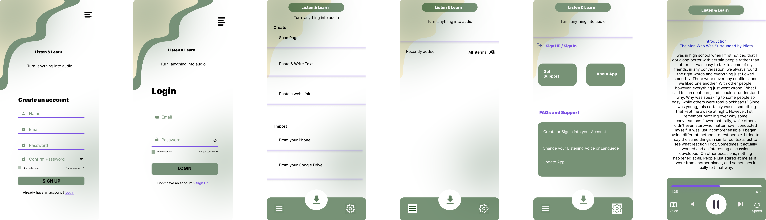

[Figma design link](https://www.figma.com/file/I9j7rQDfX8U9VY0kMfxOnS/Listen%26Learn?type=design&node-id=0%3A1&mode=design&t=GCEbPnLrxvUVKRLo-1)